**Assignment-8**

PL/SQL - I:

1. Write a PL/SQL block of code to update salary of employee ‘7788’ to 35000 if the salary is less than 35000.

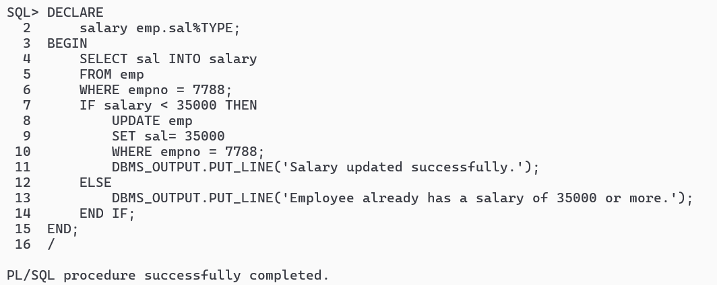

2. Write a PL/SQL block of code to insert all details of employee ‘7698’ to a new table temp_emp, which has same

structure as emp table.

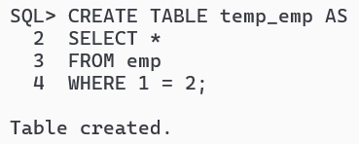

3. Write a PL/SQL block of code to display ones name like “Hello <Name>’, Whatever entered at run time.

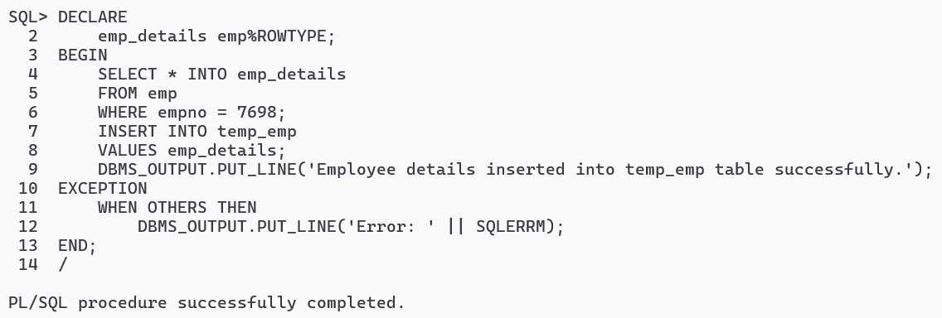

4. Write a PL/SQL block of code to print first 50 whole no.

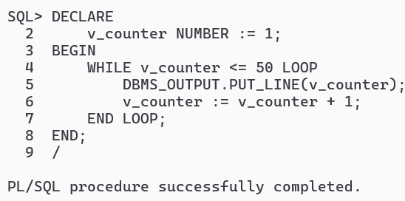

5. Write a PL/SQL block of code to update the commission of employee number 7369 to Rs. 3000 if it NULL; else

raise his commission by 25%.

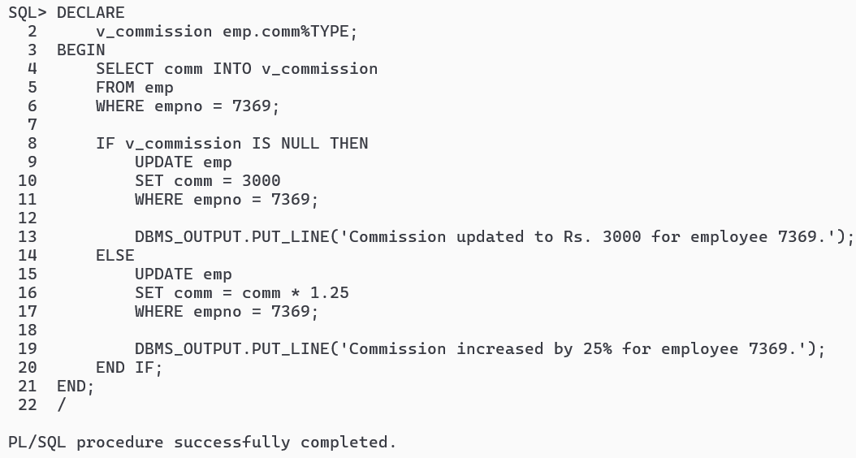

6. Write a PL/SQL block of code to print even number between 1 and 10 using for loop.

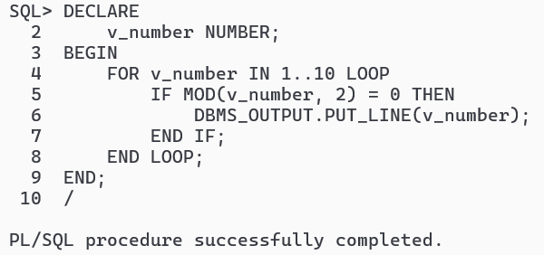

7. Write a PL/SQL block of code that will allow 5% salary increment of an employee (emp number should be

taken from user) if the employee working in the organization more than 22 year.

